Use the figures below to help answer the following questions
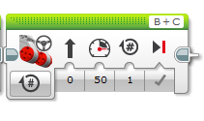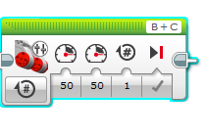
- B.

- Which block is a Move Steering Block (A or B)?

- How would you implement a turn using the Move Steering Block?

- What is a swing wide turn and how do you implement one with a Move Tank Block?
- What is a U-turn and describe how you would implement the U-turn with both the Move Tank Block?

- What is a U-turn and describe how you would implement the U-turn with both the Move Steering Block?

- Ziffle writes a program to have his robot make a 90 degree point turn to the right. Ziffle sets all the Move Block parameters properly to make a right turn and sets the Duration parameter to 90 degrees. Ziffle is disappointed to discover that his robot only turns about 60 degrees. Why did Ziffle not get the expected result?
- Describe three methods Ziffle could use to determine the correct parameters for the Move Block in questions 4 & 5.

